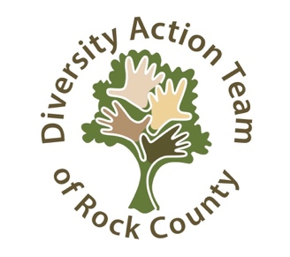

Mission Statement
The mission statement of the Diversity Action Team of Rock County is to eliminate racism and discrimination in Rock County by embracing diversity, valuing multiculturalism and fostering justice, dignity and respect for everyone.

Dear Friends,
You are invited to renew your membership or join the Diversity Action Team of Rock County (DAT). We appreciate your support of the mission. The Diversity Action Team supports events such as:

- Free Educational Programs
- Courageous Conversations
- Study Circles
- Racial Justice Conference
- Peace Week
- Martin Luther King Jr Commemoration

Please complete the form below and return it with your membership contribution.
Thank you for your support!
Sincerely,

Diversity Action Team Board of Directors
Marc Perry, President Billy Bob Grahn
Barbara Fett Neil Deupree
Santo Carfora Jose Carrillo
Jill Gant Jane Thompson
Julie Waite
Website: www.datrockco.org

Like us on Facebook: Diversity Action Team of Rock County

Diversity Action Team 2019 Annual Membership

Name _______________________________________________________________________

Address______________________________________________________________________

Phone_______________________Email____________________________________________

Levels of Giving: (check one) ____Full time student (free membership)

_____Friend $10 - $99 _____Advocate $100 - $249 _____Supporter $250 + up

_____Organizations / Businesses $100 + up (includes your name/logo on the DAT website)

Make checks payable to Diversity Action Team of Rock County

Mail to c/o Community Foundation of Southern WI
26 S Jackson St.
Janesville, WI 53547-0271

